Netflix Content Analysis

1. Objective:
This project analyze the Netflix content catalog to understand which titles, genres and content types drive the majority of user engagement. The goal is to extract insights related to viewer behavior, genre performance, Originals vs NonOriginals strategy, and factors that influence content consumption.

2. Dataset Overview:
This dataset contains 5,000 records, each representing a Netflix title.
Key fields include:
Metadata:
- title
- type
- release_year
- date_added
- age_rating
- primary_genre
- country
- language
Performance Metrics:
- views_30d
- completion_rate_pct
- imdb_rating
- user_rating
- likes
Engineering Features (Created in Python):
- content_age
- release_decade
- is_kids_friendly
- duration_bucket
- engagement_score

3. Methodology:
3.1 Data Cleaning (Python)
Performed:
- Handled NA values based on content type
- Converted date columns & categorical variables
- Cleaned inconsistent genres and ratings
- Ensured numeric columns matched expected ranges
3.2 Feature Engineering (Python)
Added meaningful analytical features:
- Engagement Score = 60% normalized views + 40% completion rate
- Kids friendly flag
- Duration buckets
- Content age and release decade
3.3 Exploratory Data Analysis (Python)
- Titles by Type, genre, year
- Rating Distribution
- Views Vs IMDb Rating
- Completion Rate Vs age rating
- Originals vs Non-Originals performance
- Correlation heatmap of engagement metrics
3.4 SQL Analysis (MYSQL)
- Top performing titles
- Avg views per genre
- Originals vs Non-originals comparison
- Country-wise performance
- Top 10 titles per genre
- Hidden gems (high rated but low views)
3.5 Power BI Dashboard
Built a 3-Page Netflix themed dashboard.

4. Power BI Dashboard Summary
Page 1 – Overview
- KPIs: Total Titles, Movies, TV Shows, Avg IMDb Rating, Total Views
- Visuals:
  - Titles by Type
  - Top 10 Genres by Views
  - Release Year Trend
  - Top Titles Table (Top 15 Titles by Views)
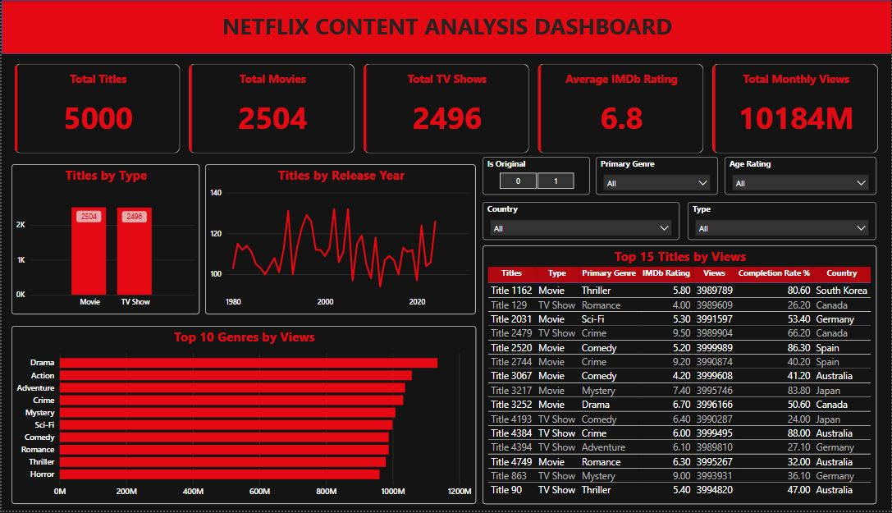

Page 2 – Originals vs Non-Originals
- KPIs: Originals % , Avg Views Originals, Avg Views Non-Originals
- Visuals:
  - Originals vs Non-originals comparison
  - Views by Genre & Type
  - Age Rating vs Completion (heatmap)
  - Top Countries by Views
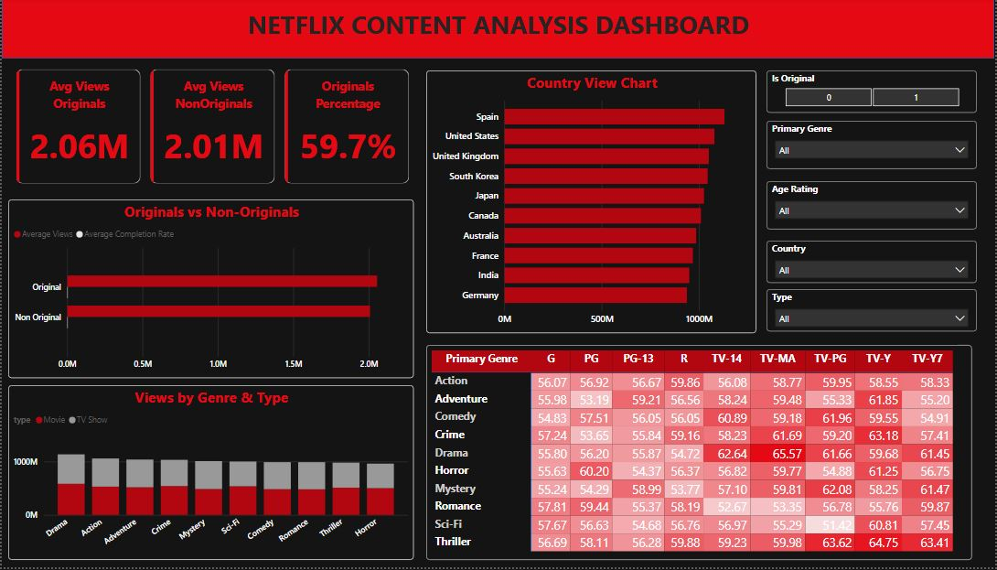

Page 3 – Engagement Analysis
- Visuals:
  - Scatter: IMDb vs Views
  - Avg Engagement Score by Genre
  - Avg Completion Rate by Type
  - High Engagement Titles Table
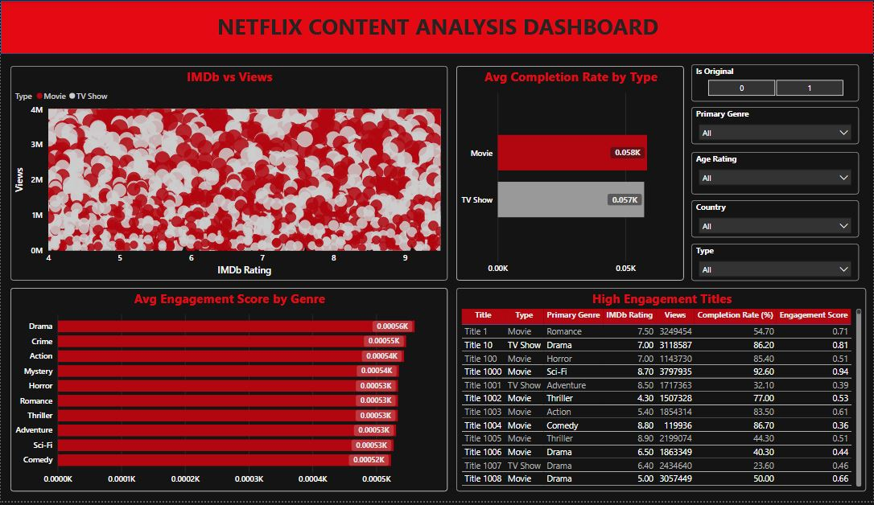

5. Key Insights:
1. Originals Outperform Non-Originals
- Higher average views
- Higher completion rate
- Higher user and IMDb ratings
This validates Netflix’s strategy of investing heavily in Originals.
2. Certain Genres Drive Majority of Engagement
Genres like:
- Drama
- Crime
- Action
- Mystery
deliver higher engagement and rewatch potential.
3. High Engagement Titles Are Not Always High Rating Titles
Some titles with average IMDb ratings have extremely high views due to:
- Strong marketing
- Viral trends
- Regional popularity
4. Kids-Friendly Content Has High Completion but Lower Views
Kids content:
- Gets high completion rate (>80%)
- But contributes only a small fraction of total views
5. A Few Titles Drive Majority of Total Views
Content follows a “hit-driven” distribution:
- Top ~10% titles contribute >50% of total views

6. Recommendations:
📌 Invest more in high-performing genres
Especially Action, Mystery, Drama, and Crime.
📌 Increase production of Originals
Since originals outperform licensed shows in views & engagement.
📌 Promote “hidden gems”
High rated but under-viewed titles could be highlighted in the app UI.
📌 Improve kids content marketing
High completion suggests strong potential.
📌 Region-based content investment
Countries with higher engagement should get targeted content production.

7. Conclusion:
This project provides a full analytical view of Netflix content performance using a modern, real-world dataset. Using Python, SQL, and Power BI, the analysis reveals strong patterns related to viewer behavior, genre strengths, Originals’ effectiveness, and engagement drivers.
This end-to-end project demonstrates:
- Data engineering
- EDA & insight generation
- SQL analytics
- Dashboard creation
- Business storytelling

